Watch History / Viewer Buckets
What Is Watch History?
Just like your internet browser has a history, on YouTube you have a watch history too.
This is a record of all the videos a user has watched on YouTube.
YouTube uses this data combined with viewer satisfaction to profile a viewer so they can determine what kind of content to show them.
If you watch a video on camera, you see more camera content. If you stop watching a channel, you eventually stop seeing the channel .

How YouTube Pushes Videos To Viewers
Imagine YouTube organizes viewers into "buckets" based on their watch history..
Each bucket contains groups of people with similar watch histories.

Examples of Buckets:
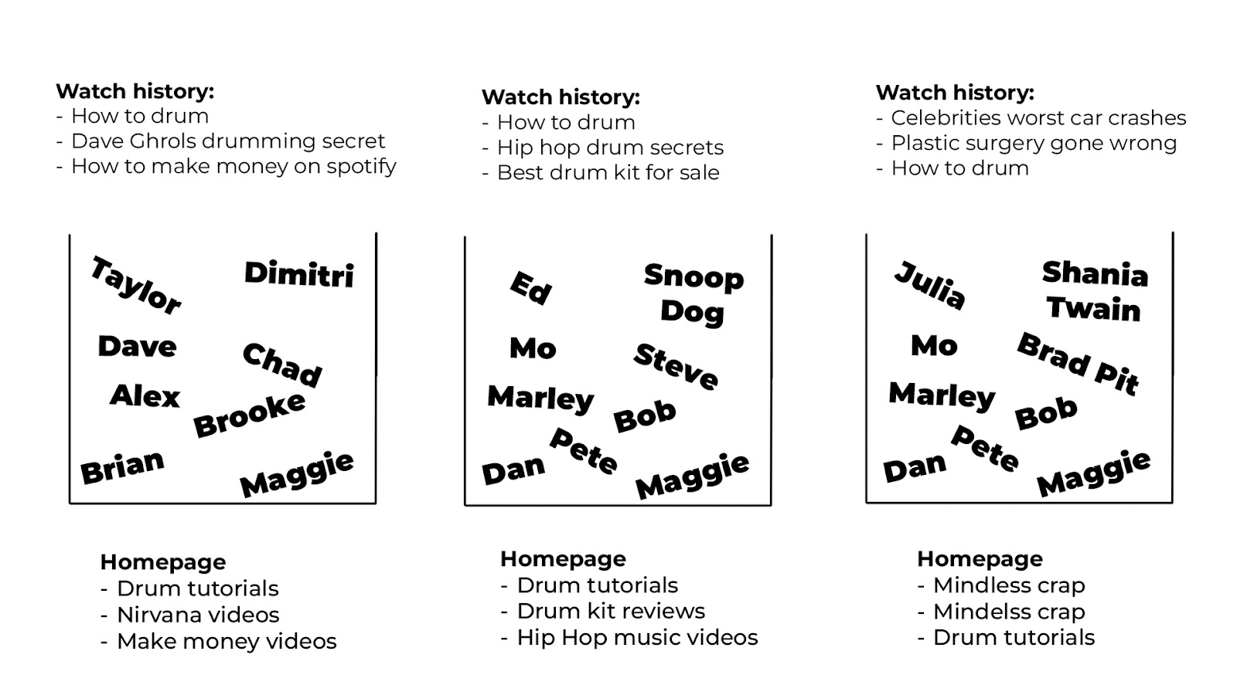

How Buckets Affect Your Video
When you post a video, YouTube tests it with specific buckets that it thinks might be interested in your video based on their watch history.
If viewer satisfaction within those buckets is high, YouTube will push it to more people in that bucket. If it is low, then it’ll stop pushing it to that bucket.

What Happens During Testing:
- Initial Testing:
  - YouTube shows your video to a small group within a bucket.
  - If these viewers show high satisfaction (e.g., watch time, likes, engagement), YouTube pushes the video to more viewers in that bucket.
- Broadening Reach:
  - If the video performs well, YouTube may test it with other similar buckets
- Underperformance:
  - If viewer satisfaction is low, YouTube may reduce or stop pushing your video to that bucket.

Key Takeaways
- Watch history groups viewers with similar interests into "buckets."
- YouTube tests your videos in these buckets to gauge performance.
- High satisfaction leads to broader promotion, while low satisfaction can halt distribution.
- Creating content aligned with your audience's interests is essential for success.
By understanding watch history and how YouTube uses buckets, you can create videos that not only reach your target audience but also keep them coming back for more.

